TurboCell Radius Authentication Setup

There are five steps to installing/configuring the Turbocell Radius Server to authenticate Radius Clients. They are listed below:

NOTE: The following is an overview. Detailed step-by-step instructions follow!

- Upload the appropriate software (*.bin file) into the TurboCell Base Station.
- Using the configuration utility, specify that the Base station will be used to authenticate users via Radius.
- Configure the Base station as a Radius Server NAS.
  - Set the system access password that will match the password in the server.
  - From the setup menu, under the 802.11 interface, set up the devices as an ISP Base with the proper settings(frequency, speed, and ID).
  - In the general menu, enable TurboCell Radius.
  - In the setup menu, select the Radius Server setup, and enter the proper settings for radius.
- Configure the Linux Radius Server to match the settings you’ve configured in the Karlnet Radius device.
  - Set up the /usr/raddb/clients file
  - Set up the /usr/raddb/users file
  - Set up the /usr/raddb/dictionary file
- Finally, set up the client to authenticate through the base to the Radius server.

The following will be used as an example setup in the remainder of this document.

Configurator Setup of the Karlnet ISP Base Station

Set “System Access Pass Phrase” in the "System Access Setup" menu.
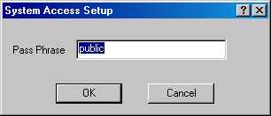

To set up the Base station:

- In interface setup set it up as an ISP Base with the correct frequency of operation, Speed, and ID.
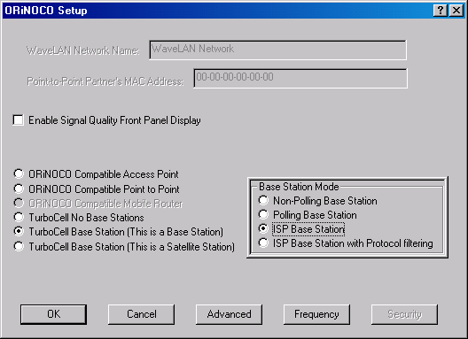

- In the general menu check the “Enable TurboCell Radius Authentication” box.
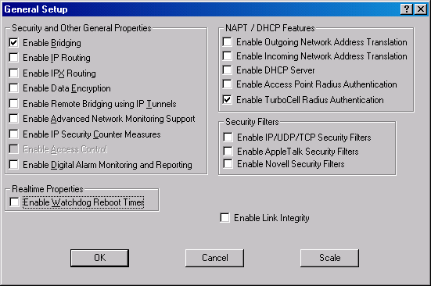

- In the RADIUS menu, input the RADIUS shared secret, the UDP port (default is 1812) and the IP address of the RADIUS server. Optionally, input a second server.
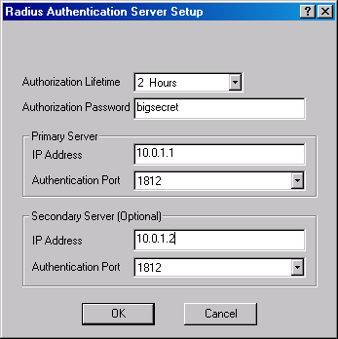
IP Address of the Linux Radius server
IP Address of the Linux Radius backup server

RADIUS Server Setup
NOTE: This setup uses radiusd-cistron.

Restarting Radius
Whenever you make changes to the Radius server setup, you must restart the Radius server.

To restart the radius server, first obtain the Radius process id by by typing 'ps –xf' as the superuser. Example output follows:

182 con- I 0:00.02 /usr/local/sbin/radiusd -y

Once you have the Radius process ID, type ‘kill –HUP 182’ (without the quotes).

/etc/raddb/clients
The IP Address of the Base Station must be included in the /etc/raddb/clients file along with the shared RADIUS secret.

# Client Name Key
#---------------- ----------
localhost testing123
10.0.1.1 testing123
10.0.1.25 bigsecret

/etc/raddb/users
Each Satellite must have an entry in the /etc/raddb/users file. A typical entry is:

11-22-33-44-55-66 Password="public"
KarlNet-TurboCell-TxRate = TxRate-Local
KarlNet-TurboCell-OpState= Up

Where:
11-22-33-44-55-66 | MAC address of the radio in the satellite. Note: This is somewhat confusing!! This is not the MAC address of the device. Instead, it is the MAC address of the RADIO CARD
Password="public” | pass phrase set in Configurator software
KarlNet-TurboCell-TxRate = TxRate-Local | Sets the bandwidth rate
KarlNet-TurboCell-OpState = Up | Sets the state of the satellite

/etc/raddb/dictionary
The list of attributes can be found in the file /usr/raddb/dictionary file. The dictionary file must contain the following currently defined list:

# --------------------------------------
# KarlNet Vendor-specific information
# --------------------------------------

#---------------------------------------------------------------------------
# "VENDOR" VENDOR-NAME VENDOR-ID
#---------------------------------------------------------------------------
VENDOR KarlNet 762

#---------------------------------------------------------------------------
# "ATTRIBUTE" ATTRIBUTE-NAME ATTR-NUMBER ATTRTYPE VENDOR-NAME
#---------------------------------------------------------------------------
# Sets the remote client's Station Name
ATTRIBUTE KarlNet-TurboCell-Name 151 string KarlNet

# Sets the remote client's Data Transmit Rate
ATTRIBUTE KarlNet-TurboCell-TxRate 152 integer KarlNet

#---------------------------------------------------------------------------
# "VALUE" ATTRIBUTE-NAME SETTING-NAME SETTING-VALUE
#---------------------------------------------------------------------------
# 0x00 // Use the locally defined Data Rate
VALUE KarlNet-TurboCell-TxRate TxRate-Local 0
# 0x08 // Use the maximum data rate possible
VALUE KarlNet-TurboCell-TxRate TxRate-MaxSpeed 8
# 0x10 // 64 Kbps (needed?)
VALUE KarlNet-TurboCell-TxRate TxRate-64k 16
# 0x18 // 128 Kbps
VALUE KarlNet-TurboCell-TxRate TxRate-128k 24
# 0x20 // 256 KBps
VALUE KarlNet-TurboCell-TxRate TxRate-256k 32
# 0x28 // 512 Kbps
VALUE KarlNet-TurboCell-TxRate TxRate-512k 40
# 0x30 // 1024 Kbps
VALUE KarlNet-TurboCell-TxRate TxRate-1Mbps 48
# 0x38 // 1581 Kbps (T1 1.544 Mbps -> 1581 Kbps?)
VALUE KarlNet-TurboCell-TxRate TxRate-T1 56
# 0x40 // Two T1's (3162 Kbps)
VALUE KarlNet-TurboCell-TxRate TxRate-2T1 64
# 0x48 // Three T1's (4743 Kbps)
VALUE KarlNet-TurboCell-TxRate TxRate-3T1 72

# Sets the remote client's Operating State
ATTRIBUTE KarlNet-TurboCell-OpState 153 integer KarlNet
VALUE KarlNet-TurboCell-OpState Up 0
VALUE KarlNet-TurboCell-OpState Down 1

# Sets the remote client's Operating Mode
ATTRIBUTE KarlNet-TurboCell-OpMode 154 integer KarlNet
VALUE KarlNet-TurboCell-OpMode Peer-to-Peer 0
VALUE KarlNet-TurboCell-OpMode Base 1
VALUE KarlNet-TurboCell-OpMode Base-Polling 2
VALUE KarlNet-TurboCell-OpMode Satellite-NT 3

# ----------------------------------------------
# END OF KarlNet Vendor-specific information
# ----------------------------------------------

To set up the satellite:

Set “System Access Pass Phrase” in the "System Access Setup" menu.

In interface setup, set it up as a satellite with the correct frequency of operation, Speed, and ID.

